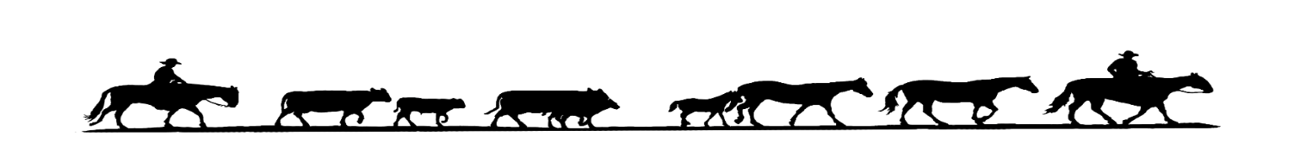Central Oregon Livestock Auction
We are now offering commingled sales at Central Oregon Livestock Auction. This involves processing cattle by commingling cattle of multiple producers into larger lots based on weight, shape, color and sex.
These larger uniform lots are attractive to more buyers; thus bringing a premium price when compared to cattle sold in drafts of less than five head. Commingling also allows the smaller producers to sell at a premium sale time.
How does it work?
- The seller, at their option, has the choice to allow his cattle to be sorted and sold with other producer’s cattle based on sex, color, frame and weight.
- Each individual animal will then be sorted by height, weight, sexed and receive an individual identification tag to determine which lot of cattle they will be co-mingled with.
- The cattle are sold on the weight through the ring. The seller will be paid on the total weight for lot divided by the head count of the lot.
- There is no charge for this service.
What are the benefits of this service?
- Cattle normally sell higher when sold in larger lots. By commingling smaller producers cattle together into larger lots, it allows them to achieve these benefits.
This marketing option is strictly up to the seller. If you would like to have your cattle commingled, please sign and date this document.
I ____________________________ give Central Oregon Livestock Auction permission to commingle my cattle on
_____________________20____.
Signed:_____________________________________

